INCLUDED IN THIS TOOLKIT:
- Sample Social Media Posts
- Sample Email Content
- Sample Email Signature Content
- Social Media Graphics

IMPORTANT DETAILS
- Early Bird Deadline: October 8, 2024
- Exhibitor-Sponsor Registration Deadline: October 8, 2024
- Hotel Reservation Deadline: October 10, 2024
- Event Dates: October 22-25, 2024
- Convention Theme: Back to Basics
- Convention website: https://www.icri.org/fall-2024-conv

SOCIAL MEDIA TIPS
- Customize the language to fit your style
- Don’t forget to use the hashtag: #ICRIFall24
- Tag ICRI in your posts
  - Facebook: https://www.facebook.com/ICRIorg
  - LinkedIn: https://www.linkedin.com/company/icrisocial/
  - Twitter/X: https://x.com/ICRI_social
- You can repost images from ICRI social media accounts or use the images at the end of this toolkit.
- Record and share a short video about what you are looking forward to from this year’s event.

Social Media Posts
Copy and paste or customize the below posts for Facebook, LinkedIn or X.

Facebook (@ICRIorg - ICRI)
- [COMPANY NAME] is dedicated to offering the most innovative [resources/etc.] for the concrete repair, protection, and restoration community. That’s why we’re excited to attend the ICRI Fall Convention, taking place October 22-25, 2024, in Denver, Colorado! Learn more about this year’s event and register now to join us there! https://www.icri.org/fall-2024-conv #ICRIFall24
- Don’t miss the ICRI Fall Convention this October in Denver! Engage with dedicated providers and build connections with concrete professionals from around the world over the 3 days of the event. See the full schedule and register today! https://www.icri.org/fall-2024-conv #ICRIFall24

LinkedIn (@ICRISocial – ICRI)
- [COMPANY NAME] is dedicated to offering the most innovative [resources/etc.] for the concrete repair, protection, and restoration community. That’s why we’re excited to attend the ICRI Fall Convention, taking place October 22-25, 2024, in Denver, Colorado! Learn more about this year’s event and register now to join us there! https://www.icri.org/fall-2024-conv #ICRIFall24
ICRI is heading to Denver for the premier event in concrete repair and restoration – the 2024 ICRI Fall Convention! Whether you're a novice or a seasoned professional, this is your chance to get “back to basics” with concrete repair, protection, and restoration…and also learn about the newest industry innovations. This event is the best opportunity to expand your knowledge through networking, technical sessions, and participation in ICRI committee meetings.
That’s we’re excited to represent [COMPANY NAME] as [an exhibitor, a sponsor, or an exhibitor and sponsor] at this year’s convention. Learn more and register now: https://www.icri.org/fall-2024-conv #ICRIFall24

Twitter/X (@icrisocial)
- Looking for practical strategies and tools when it comes to concrete repair, protection, and restoration? Join us at the ICRI Fall Convention this October!
https://www.icri.org/fall-2024-conv #ICRIFall24

Email/Newsletter Option
Use the below email template to invite colleagues and friends to the ICRI Fall Convention. Feel free to copy and paste or customize to make it your own. The more personal, the better!

We are excited to share that [COMPANY NAME] will be attending the ICRI Fall Convention, taking place October 22-25, 2024, in Denver! ICRI’s conventions are for our community—everyone from novices to seasoned professionals—and are focused on collaboration, connection, and education within concrete repair, protection, and restoration.
include this if your company is an exhibitor
In fact, [COMPANY NAME] will be showcasing [NAME OF PRODUCT OR SERVICE] in the Exhibit Hall!
include this if your company is a sponsor
[COMPANY NAME] is proud to support ICRI’s mission and vision as a sponsor of the 2024 Fall Convention.
include this if your company is an exhibitor and sponsor
[COMPANY NAME] will be showcasing [NAME OF PRODUCT OR SERVICE] in the Exhibit Hall and is a proud Convention sponsor supporting ICRI’s mission and vision.

ICRI has worked to put together a phenomenal program, which you can view here. We hope you can join us there!

Kind regards,

[YOUR NAME]

ICRI Fall Convention
October 22-25, 2024 | Denver, Colorado

Email Signature
Add the below copy and appropriate graphic to your email signature to help spread the word about the ICRI Fall Convention. Right-click the image to save — don’t forget to hyperlink the image to https://www.icri.org/fall-2024-conv.

Join me at the ICRI Fall Convention, happening October 22-25, 2024!
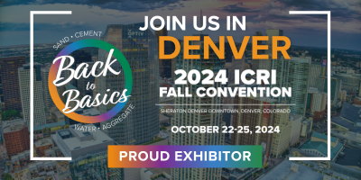

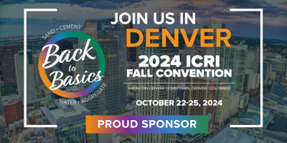

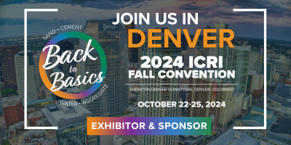

Social Media Graphics
Right click to save images (save as picture) or click here to download all images.
If modifying images to include exhibit booth number, please use Proxima Nova Bold as the font.

