INCLUDED IN THIS TOOLKIT:
- Sample Social Media Posts
- Sample Email Content
- Sample Email Signature Content
- Social Media Graphics

IMPORTANT DETAILS
- Early Bird Deadline: March 31, 2025
- Exhibitor-Sponsor Registration Deadline: March 31, 2025
- Hotel Reservation Deadline: March 25, 2025
- Event Dates: April 13-16, 2025
- Convention Theme: Keep Concrete Weird: Unusual Projects
- Convention website: https://icri.org/2025-spring-conv

SOCIAL MEDIA TIPS
- Customize the language to fit your style
- Don’t forget to use the hashtag: #ICRISpring25
- Tag ICRI in your posts
  - Facebook: https://www.facebook.com/ICRIorg
  - LinkedIn: https://www.linkedin.com/company/icrisocial/
  - Twitter/X: https://x.com/ICRI_social
- You can repost images from ICRI social media accounts or use the images at the end of this toolkit.
- Record and share a short video about what you are looking forward to from this year’s event.

Social Media Posts
Copy and paste or customize the below posts for Facebook, LinkedIn or X.

Facebook (@ICRIorg - ICRI)
- [COMPANY NAME] is dedicated to offering the most innovative [resources/etc.] for the concrete repair, protection, and restoration community. That’s why we’re excited to attend the ICRI Spring Convention, taking place April 13-16 2025, in Austin, Texas! Learn more about this year’s event and register now to join us there! https://icri.org/2025-spring-conv #ICRISpring25
- Don’t miss the ICRI Spring Convention this April in Austin! Engage with dedicated providers and build connections with concrete professionals from around the world over the 3 days of the event. See the full schedule and register today! https://icri.org/2025-spring-conv #ICRISpring25

LinkedIn (@ICRISocial – ICRI)
- [COMPANY NAME] is dedicated to offering the most innovative [resources/etc.] for the concrete repair, protection, and restoration community. That’s why we’re excited to attend the ICRI Spring Convention, taking place April 13-16, 2025, in Austin, Texas! Learn more about this year’s event and register now to join us there! https://icri.org/2025-spring-conv #ICRISpring25
- Get ready to embrace the unconventional and celebrate the extraordinary at the 2025 ICRI Spring Convention. Whether you're a novice or a seasoned professional, this event is your chance to explore the most unusual and innovative projects in concrete repair, protection, and restoration. Expand your knowledge through networking, technical sessions, and participation in ICRI committee meetings!
That’s we’re excited to represent [COMPANY NAME] as [an exhibitor, a sponsor, or an exhibitor and sponsor] at this year’s convention. Learn more and register now: https://icri.org/2025-spring-conv #ICRISpring25

Twitter/X (@icrisocial)
- Looking for practical strategies and tools when it comes to concrete repair, protection, and restoration? Join us at the ICRI Spring Convention this April!
https://icri.org/2025-spring-conv #ICRISpring25

Email/Newsletter Option
Use the below email template to invite colleagues and friends to the ICRI Spring Convention. Feel free to copy and paste or customize to make it your own. The more personal, the better!

We are excited to share that [COMPANY NAME] will be attending the ICRI Spring Convention, taking place April 13-16, 2025, in Austin, Texas! ICRI’s conventions are for our community—everyone from novices to seasoned professionals—and are focused on collaboration, connection, and education within concrete repair, protection, and restoration.
include this if your company is an exhibitor
In fact, [COMPANY NAME] will be showcasing [NAME OF PRODUCT OR SERVICE] in the Exhibit Hall!
include this if your company is a sponsor
[COMPANY NAME] is proud to support ICRI’s mission and vision as a sponsor of the 2025 Spring Convention.
include this if your company is an exhibitor and sponsor
[COMPANY NAME] will be showcasing [NAME OF PRODUCT OR SERVICE] in the Exhibit Hall and is a proud Convention sponsor supporting ICRI’s mission and vision.

ICRI has worked to put together a phenomenal program, which you can view here. We hope you can join us there!

Kind regards,

[YOUR NAME]

ICRI Spring Convention
April 13-16, 2025 | Austin, Texas

Email Signature
Add the below copy and appropriate graphic to your email signature to help spread the word about the Spring Convention. Right-click the image to save — don’t forget to hyperlink the image to https://icri.org/2025-spring-conv

Join me at the ICRI Spring Convention, happening April 13-16, 2025!
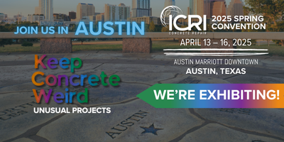

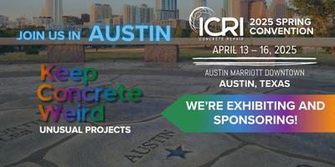
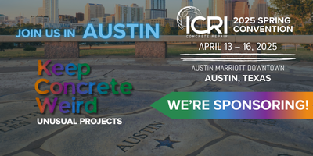

Social Media Graphics
Right click to save images (save as picture) or click here to download all images.
If modifying images to include exhibit booth number, please use Proxima Nova Bold as the font.

